**Digital Image Processing Quiz 3**

**Deadline: 12am March 9**

**Don’t copy others, or neither of you will get the score.**

**Student Number : 2017002106**

**Name : Mahadi Sajjad Neloy**

What is image rotation? Why we need rotate images in computer vision(you can give me an example to explain)?

Ans: Image rotation is a common image processing routine with applications in matching, alignment, and other image-based algorithms. The output is the same size as the input, but the out of edge values are dropped. Image rotation is performed by computing the inverse transformation for every destination pixel. Output pixels are computed using bilinear interpolation. RGB images are computed by evaluating one color plane at a time. This is necessary in order to achieve the perfect viewing vector of an image to analyze it. For example, Satellite Images of Earth taken from Orbital Sources often need to be rotated so that people can analyze the data.

1. What is masking? What circumstances do you think we need to use masking in computer vision(you can give me an example to explain)?

Ans: Masking is an image processing method in which we define a small 'image piece' and use it to modify a larger image. Masking is the process that is underneath many types of image processing, including edge detection, motion detection, and noise reduction. Using a mask allows us to focus only on the portions of the image that interests us. Masking can be extremely useful in situation where the source image is full of elements that are of no interest to the data we want to analyze. Then we can simply keep a small window with target in sight and mask the rest,

3. Programming: submit the codes and results.

Please rotate an image by 60 degrees, then shrink the rotated image by 0.4(you can select an image). Of course, you can just practice the codes in lecture 5.

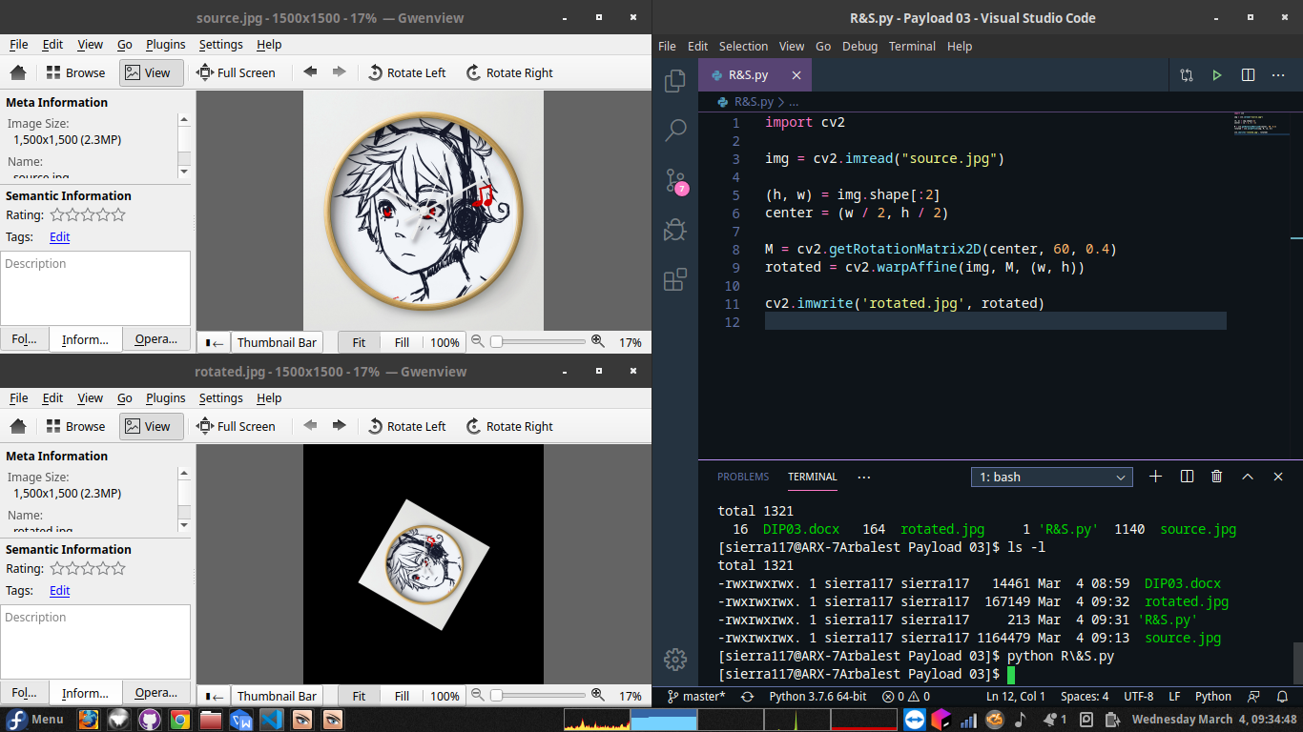

4. Programming: submit the codes and results.

Please make a circular mask with a radius of 80 on an image(you can select an image). Of course, you can just practice the codes in lecture 5.

